**Education**

**_____________________________________________________________________________________________**

**Brigham Young University - Idaho,** Rexburg, Idaho **Sept. 2012 - Present**

Online Student

*Bachelor of Science - University Studies*

*Minor: Marriage and Family*

*Cluster 1: Administrative Assistant*

*Cluster 2: Pre-Law*

**Lone Star College,** Houston, Texas **Jan. 2015 - Dec. 2015**

*Paralegal Studies Certificate (A.B.A. Approved Program)*

**Experience**

**_____________________________________________________________________________________________**

**Haley & Olson PC,**  Waco, Texas **May 2017 - Present**

**\*\*Just started working here...I need to add my responsibilities\*\***

**Gordon Law Firm,** Idaho Falls, Idaho **Feb. 2016 - April 2017**

*Legal Assistant/Paralegal*

* Responsible for starting and maintaining each new case file
* Gather police reports, medical records, medical bills, photographs and other supporting evidence
* Prepare, draft, and send documents such as letters of representation, medical releases, and requests for records to the appropriate provider
* Contact insurance companies and adjusters on a daily basis
* Call medical providers to get current balances on the client's account
* Responsible for gathering and distributing all incoming correspondence such as fax, mail, and phone calls
* Maintain the office electronic and paper filing systems
* Notar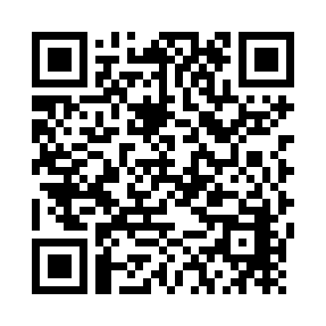y Public for the state of Idaho

**Griffin & Griffin PLLC,** Houston, Texas **Aug. 2015 - Dec. 2015**

*Legal Assistant/Paralegal Intern*

* Drafted and prepared legal documents for attorney review with 100% prior to deadline
* Completed applications and forms for visa applicants and organized client information for visa packets.
* Filled out applications for company amendments through the Texas Secretary of State
* Organized client material to appropriate matter files and sent documents to the courts
* Sent email reminders to clients for overdue billing through QuickBooks
* In charge of organizing and maintaining filing systems

**BYU-Idaho Support Center,** Rexburg, Idaho **April 2014 - Dec. 2014**

*Information Specialist*

* Answered roughly 50 telephone calls daily and gave information to callers, took messages, or transferred calls to the appropriate departments
* Greeted around 100 visitors daily, handled their inquiries, and directed them to the appropriate persons
* Maintained paper and electronic filing systems for records, correspondence, and other material
* Learned to operate new office technologies as they were implemented
* Used programs such as Excel, Office, database management, and other applications

**_____________________________________________________________________________________________**

Other work experience includes: Customer service and sales

**Find me on LinkedIn**